User Guide

Running the Automation Tests

To run the tests

<https://chromedriver.chromium.org/getting-started>

In order to run the automation test, you may need to navigate to WebDriverSetUp in the AutomationTest project, where I have the url ‘localhost:5050:/Home/SelectContinent, you may have to change this to the name of your local host.

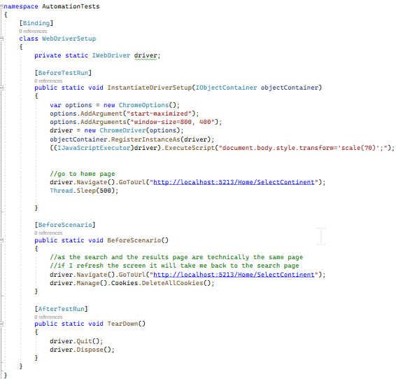

To run the automation test, you’ll need to have an instance of the SynopticProjectChatAgent running. This can be achieved by clicking this button: 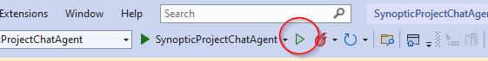

.

DATABASE:

I have included deployment scripts that you can run in order to insert the data from my project into you database

Project:

To run the project locally, click on the start button.

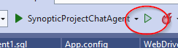

Guide:

On each page enter in a value and press submit.

Once you have entered in you Temp Value, you will see the filtered results page.